Changes document for MS Decom activities

Project: z2f81_wpfis

System : xFE

CD: 151938.

Transport request: DFEK962733

—---------------------------------------------------------------------------------------------------------------------------------

1. myComp => Manage CFolder

Added a new button for the Export to my Drive option.

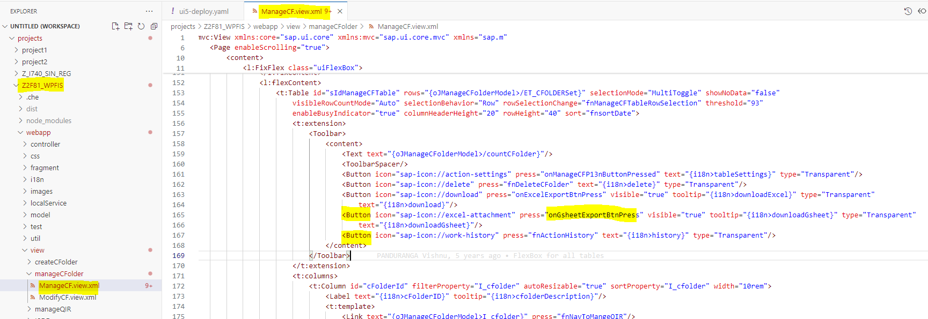

Below function to trigger on Export to my Drive button to filter the data and export to gsheet.

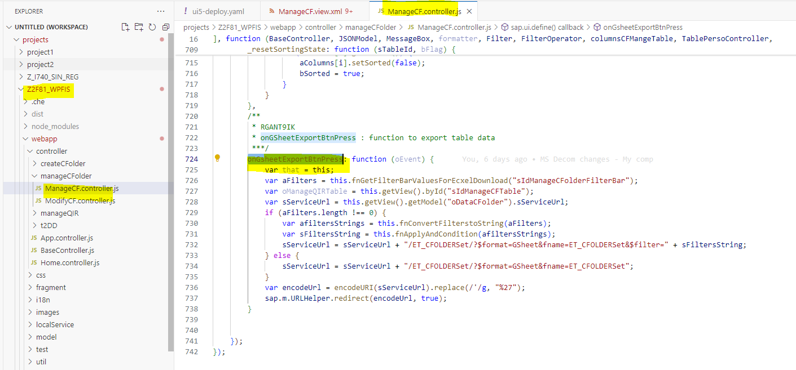

1. myComp => Manage QIR

Added below highlighted button for Export to my Drive option in the view.

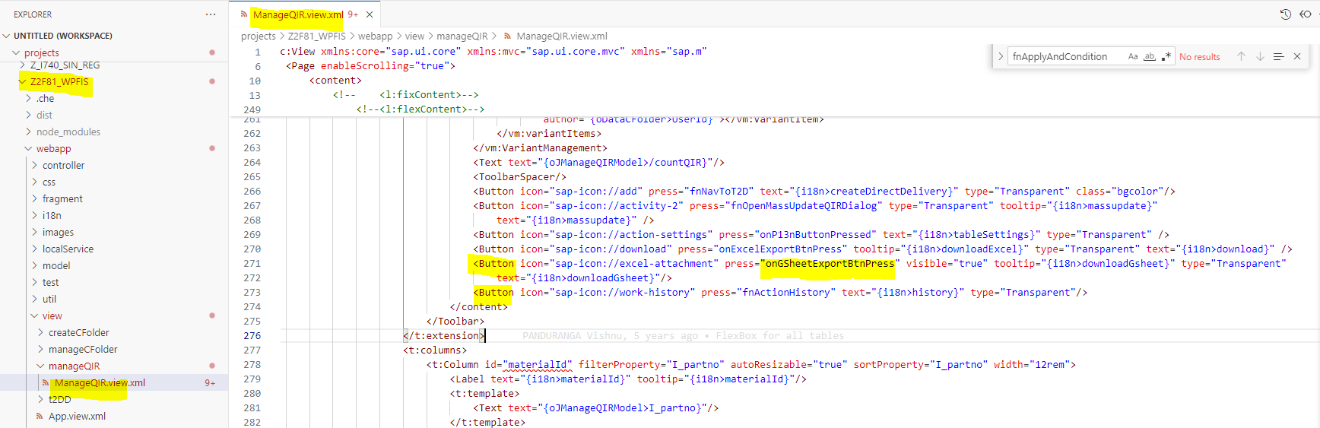

Below is the function in controller file to fetch the filtered data and export into gsheet.

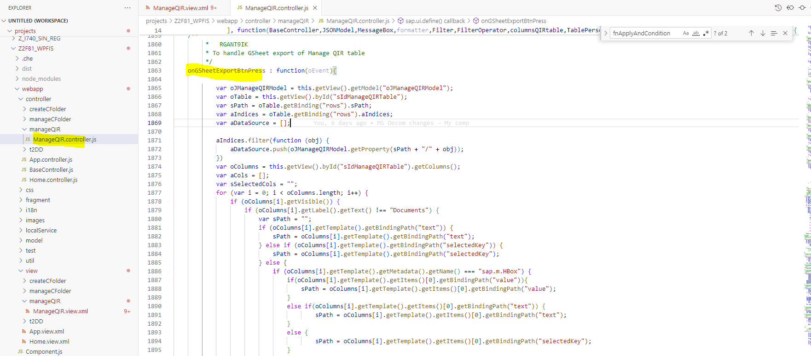

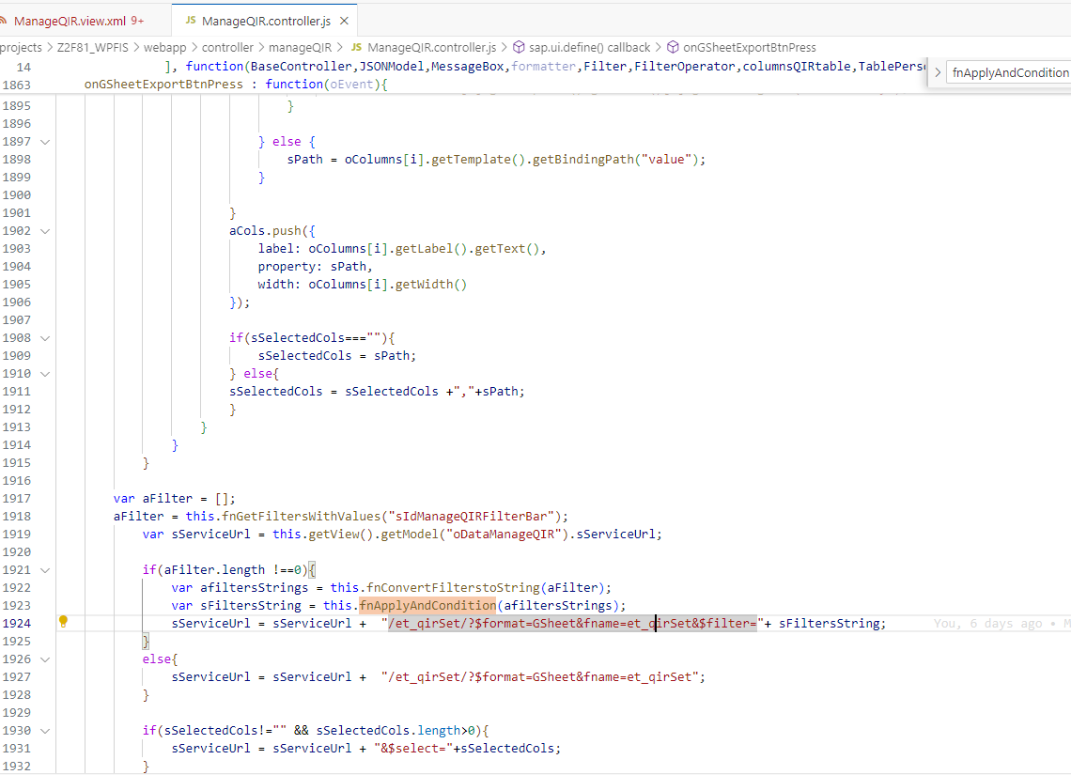

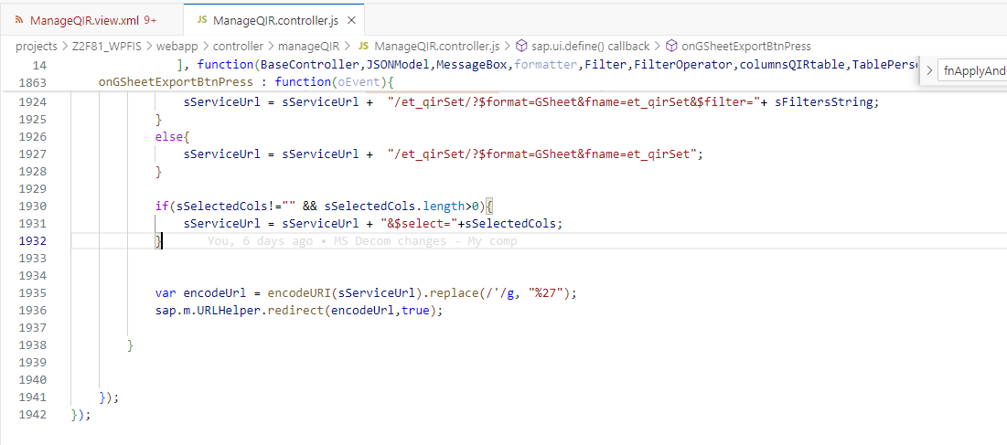

1. myComp => T2DD

Adding button in the view for Export to my Drive option.

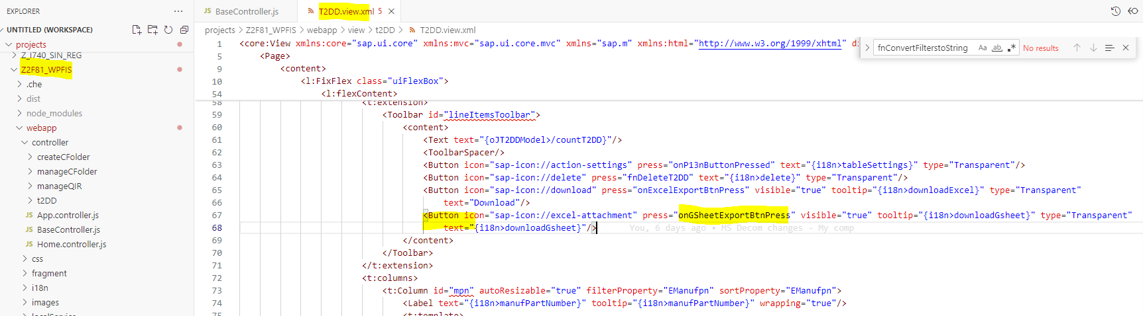

Below is the function that will trigger the Export to my Drive button. It will export the data into gsheet by including all the filtered data from the result table.

